Item: Two point touch discriminators/calipers
Number in Inventory: 15
Supplier: Carolina, Item #696417
Cost: $8.50 each
Purchased via: Dana Lending Library

Topic: Sensory system, Touch, Receptive Fields
Grade Levels: 4th through high school
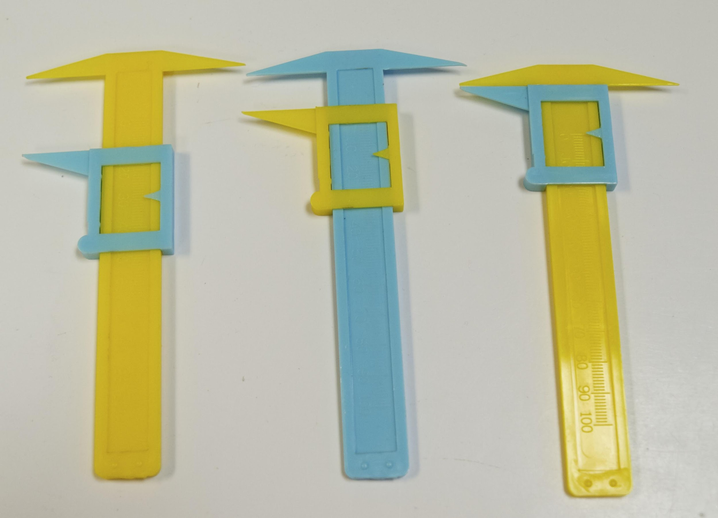
Activity: Two point touch discrimination.
Have students break into pairs or small groups. One student (the subject) closes their eyes or looks away while their partner (the tester) tests the sensitivity of different areas of the body by opening and closing the calipers and gently touching either the two-tip or one-tip side to the cutaneous area. Good areas to test include the fingertips, shoulder, elbow, forearm, palm, or back of the hand. The subject reports whether they sense one or two distinct points each time the tester touches. The tester records the measurement of the smallest opening of the calipers (in mm) at which the subject correctly identifies two distinct points.
By testing different areas, the students will discover that some parts of their bodies are better able to discriminate between the two points than other areas. Why is this? Discuss receptive fields and the organization and distribution of sensory receptors over the body.
Have students record their measurements and present their data. This is a great activity for creating group statistics by pooling and averaging the recordings from all the groups in the class – create a histogram on the board for each area of the body.

More Resources or Special Notes:
- See Eric Chudler’s section on this activity and its background concepts here (very useful): http://faculty.washington.edu/chudler/twopt.html
- The two-point touch discriminators can also be used to have students design their own experiments. Encourage them to develop clear hypotheses and experimental approaches.
- The tips of the calipers are easily bent – check to make sure students have ones where both ends of the two-point side are relatively even with each other.
- Discourage students from testing their tongues/lips.

