LESSON PLAN NAME: Two Point Touch

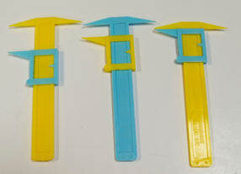
Topic: Sensory system, Touch, Receptive Fields
Developed by: Alexis Hill (2013)
Grades: 4th through high school (K-5 adaptable)
Vocabulary words: neuron, sensory receptor, density,
Materials: Powerpoint slide of animal brains and/or brain specimens and gloves; pipe cleaner neurons, optional: disposable lab gear / PPE (gowns, booties, masks, hair nets, gloves)

Time needed: 15-30 minutes
Introduction (15 min): What is a scientist? | Activity 1: Dress up like a scientist
Neuroscientists and neuroscience (5 min)
Parts of the brain (5 min)
Activity 2: Comparing animal brains (15 min)
All brains are made of Neurons! (5 min)
Activity 3: Pipe cleaner neurons (15 min)

Summary: This lesson introduces how the brain collects information about our surroundings. Our sense of touch is mediated by sensory receptors all over our skin. Different parts of our skin need to be more sensitive to touch than others - the most sensitive parts of our skin have more touch receptors than the ones that are less sensitive. We can measure this sensitivity ourselves using our two point discriminator calipers. This activity allows the kids to think about which parts might be more or less sensitive and form hypotheses that they can test on the spot.

Prerequisites for Students: Helpful if students know what the brain does and have a concept of cells.

Learning Goals:
- Learn what a sensory receptor is.
- Receptor cells communicate with your brain to tell you about your environment.
- There are different amounts (densities) of these receptors in different parts of your body because some parts need to be more sensitive to touch than others.
- Learn how to create a hypothesis, then test it.

Background for instructor:
- Refresh basic knowledge what the brain does - specifically that it communicates with the rest of the body to find out all kinds of information (5 senses).
- Refresh basic knowledge of parts of a neuron (slides provided).
- Neurons receive information from sensory neurons from all over the body.
- There are higher densities of touch receptors in our fingers than on our arms and this corresponds to shorter distances for two point discrimination.

Set-up: Print out charts for collecting sensitivity information. Have calipers ready, usually one caliper for every two students.

Lesson Outline:

1. Two people are required. One person administers the test, the other is the volunteer. If business is slow, you can administer the test. If there are many people around, tell them to pair up and take turns with each role.
2. Ask the volunteer to put out the tip of their index finger and close their eyes. Start with the caliper closed (2 sharp points feel like 1 point). Ask the volunteer how many points they feel (should be 1). Slowly slide down the moveable piece of the caliper while re-poking the volunteer until they say they can feel 2 points, and note how wide the caliper is open at this time. (For the tip of the index finger, people can often feel the 2 points as soon as the caliper is visibly open)
3. Next, test another part of the body. The cheek works very well (and is convenient in winter if everyone is wearing jackets), the upper arm also can work. Make sure the students are careful with the calipers and don’t hurt each other. [At this point, you can ask older students whether they think the distance required to feel the 2 points will be the same or larger than for the tip of the finger. Point out that this is their hypothesis.] Again, start with the caliper closed, where the volunteer should feel only 1 point. Slowly open the caliper while re-poking until the volunteer feels 2 points. The distance required to feel the 2 points should be much greater than for the tip of the index finger. Point this out.
Explanation:
Our sense of touch is mediated by sensory receptors, which are all over our skin. The density of receptors is different for various parts of the body. This makes sense, right? We need to be able our touch to be more sensitive for the tip of the index finger than for our cheek, so we can use our fingers to do intricate things like type, or sew or play a musical instrument. The density of sensory receptors for various parts of the body are coordinated with the size of the brain region that interprets these signals. The brain region involved in interpreting sensory signals forms what is called a homunculus (see figures on next page). Homunculus means little man. Here is a diagram that represents the size of the brain region designated for each part of the body. Notice how big the lips and fingers are, which have a very high density of sensory receptors, compared to the stomach and legs, which have lower densities of sensory receptors.
Additional activities for classroom setting:
For a classroom lesson, students can test various parts of the body. Good areas to test include the fingertips, shoulder, elbow, forearm, palm, or back of the hand. The subject reports whether they sense one or two distinct points each time the tester touches. The tester records the measurement of the smallest opening of the calipers (in mm) at which the subject correctly identifies two distinct points. By testing different areas, the students will discover that some parts of their bodies are better able to discriminate between the two points than other areas. Have students record their measurements and present their data. This is a great activity for creating group statistics by pooling and averaging the recordings from all the groups in the class – create a histogram on the board for each area of the body.

Wrap-up, final thoughts: The sensitivity of touch (the ability to feel two points of touch that are very close) depends on: 1. Receptor density (how many receptors there are in a given piece of skin), 2. Receptive field size (how big the area of skin is that one sensory receptor neuron responds to)
-Do we have other types of sensory neurons? (Yes, we have different types of sensory receptor neurons for all of our senses, for example on our tongue for taste, in our each for hearing, etc.) The general idea of taking information in from our environment through sensory neurons and sending that information to the brain is how all of our senses work!

NOTES:
- See Eric Chudler’s section on this activity and its background concepts here (very useful): http://faculty.washington.edu/chudler/twopt.html
- The two-point touch discriminators can also be used to have students design their own experiments. Encourage them to develop clear hypotheses and experimental approaches.
- The tips of the calipers are easily bent – check to make sure students have ones where both ends of the two-point side are relatively even with each other.
Discourage students from testing their tongues/lips.
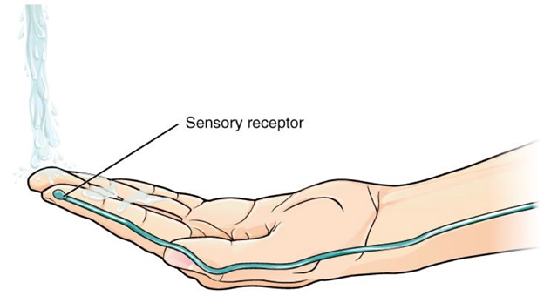

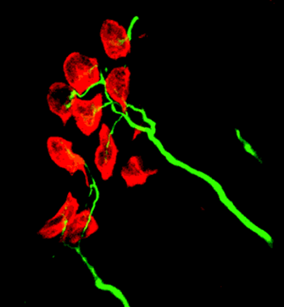
Merkel cell- a touch receptor studies in Ellen Lumpkin’s lab here at Columbia!
(from http://www.nature.com/neuro/journal/v1/n1/full/nn0598_5.html)
Merkel cells (red) within the skin, innervated by mechanosensory axons (green). The axon terminals contain the force transduction machinery, which remains poorly understood. The Merkel cells convey the mechanical stimulus from the surface of the skin to the axon terminals.
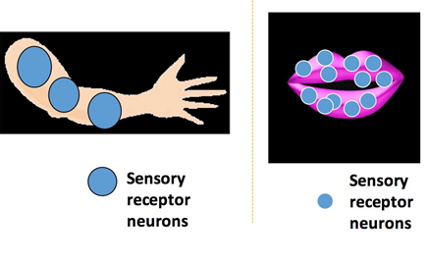
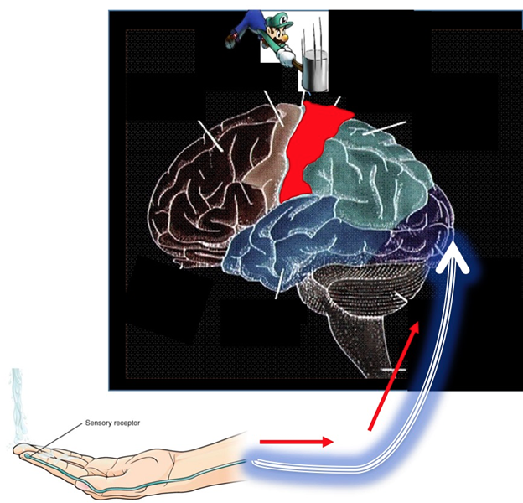
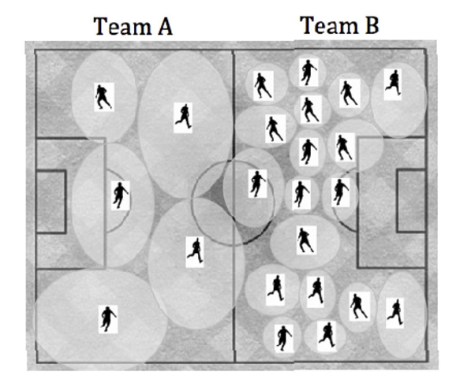
-Would you have more touch sensitivity in condition A or B?

Skin area | Minimum Distance for 2 point discrimination (cm)  1st time 2nd time
Upper arm

Palm of hand
Back
Lower arm
Leg

