INSTRUCTOR GUIDE TEMPLATE

ACTIVITY TITLE: Two-Point-Touch Discrimination

*Theme: | What makes a sense?
*Objective(s):  (What key learning do you want students to come away with?) | Understand the general path sensory information takes from the outside environment to get to the cortex, what sensory receptors are, how receptor size and density affects touch sensitivity.

LESSON OUTLINE:
1. Introduction:  Plan a script of what you will say to start.  - What will this be about? Why’s it interesting?  (Hook) | Think about one of your favorite hobbies- what senses are you using when you do it? Basically everything you do, from eating to dancing, requires your senses to take in information from your surroundings! (eg. basketball- you need vision, hearing, and touch).  You use your senses to gather information from the outside world so that you know what’s going on around you.

2. Building Background:  List questions you can use to immediately engage your audience and prepare their thinking for your activity.  -What prior knowledge might they have about/related to your topic?  -What prior knowledge (background) do they need for your activity? | What are the main 5 human senses? [vision, smell, hearing, taste, touch] What do we need these senses for?  Touch is sensed by sensory receptors in our skin (can do lock and key analogy to explain receptor). [Can show merkel cell image now.] Sensory receptor neurons are neurons in the skin that receive information about the environment, and then send that information up the spinal cord to the brain. The brain then processing the information and decides on a behavior (eg. water is dripping on my hand, I should move my hand?). The part of the brain that receives the touch information is a strip at the top of the brain, called the somatosensory cortex. [Show labeled picture of brain, point to somatosensory cortex.]  The skin on some parts of the body has more receptors than in other parts. For example, your arm has fewer/bigger sensory receptor neurons than your lips, which have smaller/more sensory receptor neurons. Which part of your body would be more sensitive to touch (show corresponding diagram) Otherwise put, will a neuron with a bigger or smaller receptive field have more touch sensitivity? [answer: lips- more receptors in an area means the area will be more sensitive]  This might make more sense if you think about a receptive field as the area a soccer player is charge of getting the ball, where the soccer player would be the neuron and the area they’re in charge of is the receptive field. [show diagram]. If you have lots of players close together, with small areas to guard (group B), that team will be more sensitive to small changes in where the ball is- a slightly different location will lead to a different player responding. In group A, the ball can move a lot and there isn’t any difference for which player gets the ball (or, less sensitivity).  Why have different sensitivities in different skin areas? How could this be useful for survival?

3. Lesson & Activity:  Outline the key components of your lesson.  Plan/Note:  - key ideas/ vocabulary  - scaffolds  - images/media  - extension questions  *Consider how to best deliver your content!  *Plan interactive components that encourage active thinking in your students. | Receptive field: The region of the skin that a sensory receptor neuron will respond to if touched.  How can we test the touch sensitivity of different parts of our body? Sensitivity of touch is the ability to feel two points of touch that are very close. So, we will place calipers on different body parts and see if we can feel one or two points. We will do this on the upper arm, palm of hand, and back. Starting with the calipers as far apart as possible, place on your partner’s selected skin area while your partner closes their eyes, and write down whether your partner felt one or two points. Move calipers one cm closer each time (check that the calipers units are cm), and continue until your partner only feels one point. Repeat for all 3 body parts, and then switch roles so that both of you place the calipers and have them placed on you. If you have extra time you can do more body parts! Record your results in the chart. (If there’s time, they can also plot their results in a bar graph)

4. Wrap Up:  - Review key ideas  - Share takeaways and final thoughts  - Discuss connections to other questions and ideas. Extensions.  - Ask: Who could you teach what you learned here today?  - Ask/Suggest: What can I do to learn more? | The sensitivity of touch (the ability to feel two points of touch that are very close) depends on: 1. Receptor density (how many receptors there are in a given piece of skin), 2. Receptive field size (how big the area of skin is that one sensory receptor neuron responds to)  -somatosensory cortex  -sensory receptor neurons  -Do we have other types of sensory neurons? (Yes, we have different types of sensory receptor neurons for all of our senses, for example on our tongue for taste, in our each for hearing, etc.) The general idea of taking information in from our environment through sensory neurons and sending that information to the brain is how all of our senses work!

MATERIALS NEEDED: **(please list all items and quantities necessary for preparation)
Several 2 point discriminator calipers. Make sure that when the sliding part is pushed all the way up, the 2 sharp ends form what feels like a single point on the pad of your index finger. (If this is not the case, don’t use it.) Ask rowdy children to be careful with the calipers, as they are easily bent out of shape. Pencil and paper (at least 1 per group), printed out chart and plot axes.

**attach any printouts to end of document here
SKILLS AND BADGES:

NOTES:
- See Eric Chudler’s section on this activity and its background concepts here (very useful): http://faculty.washington.edu/chudler/twopt.html
- The two-point touch discriminators can also be used to have students design their own experiments. Encourage them to develop clear hypotheses and experimental approaches.
- The tips of the calipers are easily bent – check to make sure students have ones where both ends of the two-point side are relatively even with each other.
Discourage students from testing their tongues/lips.
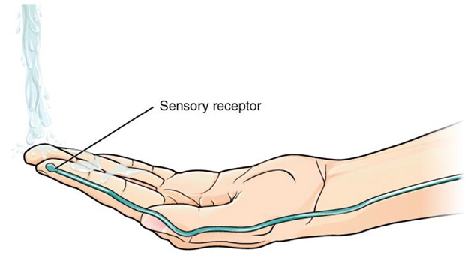

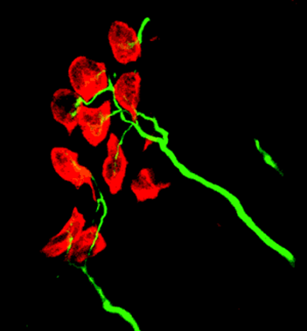
Merkel cell- a touch receptor studies in Ellen Lumpkin’s lab here at Columbia!
(from http://www.nature.com/neuro/journal/v1/n1/full/nn0598_5.html)
Merkel cells (red) within the skin, innervated by mechanosensory axons (green). The axon terminals contain the force transduction machinery, which remains poorly understood. The Merkel cells convey the mechanical stimulus from the surface of the skin to the axon terminals.
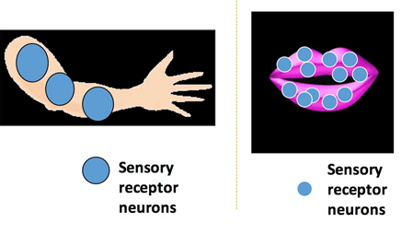
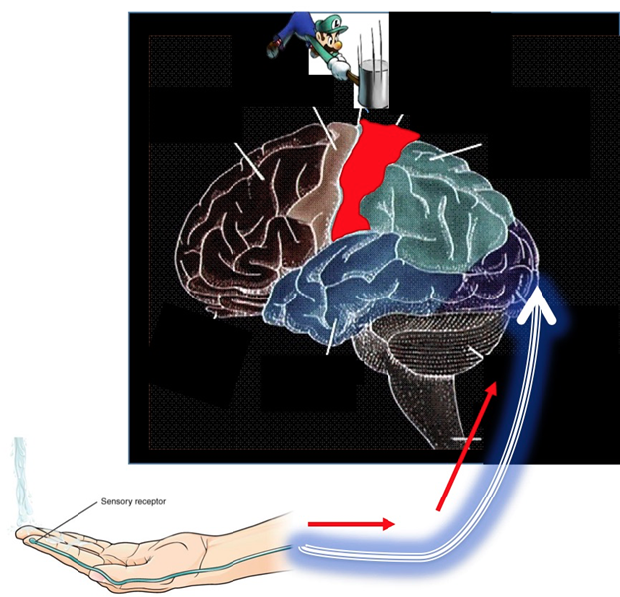
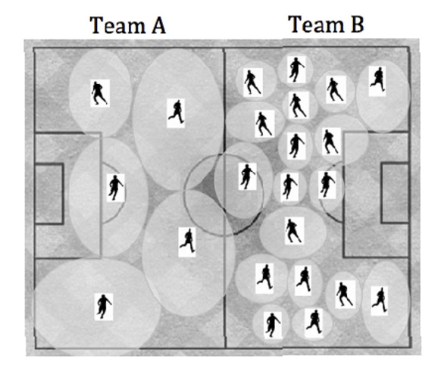
-Would you have more touch sensitivity in condition A or B?

Skin area | Minimum Distance for 2 point discrimination (cm)  1st time 2nd time
Upper arm

Palm of hand
Back
Lower arm
Leg

