ACTIVITY TITLE: Synapse Pong

*Theme: | Neurotransmission
*Objective(s):  (What key learning do you want students to come away with?) | 1. Learn how neurons communicate using neurotransmitters.  2. Learn what neurotransmitters are, and examples of major neurotransmitters (i.e. GABA, dopamine).  3. Learn about synaptic diversity, and the theory behind the correlation of the size and strength of synapses.

LESSON OUTLINE:
1. Introduction:  Plan a script of what you will say to start.  - What will this be about? Why’s it interesting?  (Hook) | [Greeting: i.e. Hey everyone, how’s your day going? Ask what they’ve learned so far], do you all know what your brain is made of? What are some guesses? [prompt attendees towards neuron]. That’s right, your brain is made up of millions of cells called neurons [begin to show a picture of a neuron. Quiz the attendees on the parts of a neuron! Dendrites, cell body, axon, and synapse are all important parts to point out]. Every day, whether you’re listening to music, walking outside, learning in a classroom, or even eating, your neurons are sending messages to each other. But here’s a question for you: how do they think they communicate? Do we know why they need to communicate?  Neurons need to communicate because you want to send your thoughts and other information gathered from your senses across pretty large distances very quickly. For example, when you pick something up, like a glass of water, there’s one part of your brain devoted to seeing and another to moving, and to link those two events together your neurons have to talk with each other. But how is this actually done? One way that neurons communicate is by using chemical cues. These chemicals are called neurotransmitters and they’re like messengers that neurons use to exchange information. Do you think neurotransmitters just float around the brain or are they confined to certain areas? Neurons convey an effective and specific message by releasing neurotransmitters in a unique area called the synapse [show picture of two synapsing neurons and a diagram of the synapse]. Synapses are formed by neurons that come in close contact with each other and that’s where neurotransmitters are released. In this activity, we’re going to learn how synapses work by playing a game where we will try to effective send neurotransmitters (show pom-poms) into the cups on the other side of our synapse board, which represent our receptors…

2. Building Background:  List questions you can use to immediately engage your audience and prepare their thinking for your activity.  -What prior knowledge might they have about/related to your topic?  -What prior knowledge (background) do they need for your activity? | No prior knowledge is needed – the volunteer running the activity should use the relevant diagrams of neurons and synapses to briefly go over before the activity begins as discussed in the introduction.  Possible questions:  Will some neurotransmitters (pom poms) be easier than others to get into the cup?  What factors will makes it easier or more difficult to successfully transmit a message? (i.e. more cups, smaller/specific transmitter vs. unspecific larger transmitter)  How do you think this activity relates back to synaptic strength?

3. Lesson & Activity:  Outline the key components of your lesson.  Plan/Note:  - key ideas/ vocabulary  - scaffolds  - images/media  - extension questions  *Consider how to best deliver your content!  *Plan interactive components that encourage active thinking in your students. | At the beginning of the activity, sparsely place cups on the post-synapse to present a slight challenge for tossing the neurotransmitters into them. Let two to three attendees pick their neurotransmitter (use three different sizes/colors) and have them take turns trying to toss them into the receptor cup. After their pool of transmitters is exhausted, count how many of each neurotransmitter made it into the cup. Rather than frame it as ‘winning’ ask the attendees what they think having more exposure to one type of neurotransmitter over another means for the neuron. For example, if more GABA made it into the cup, is that synapse going to become more excitatory or inhibitory?  Part II: Everyone now starts with whatever chemical made it into the cup most during the last round. The objective is to get all the cups onto the board in three minutes, explained as follows: the group starts with one cup and whenever a pom pom makes it into the cup then another cup is added (this can be sped up by doubling the number of cups, so if you have two cups and get a neurotransmitter in you add two more cups to the board, then four, etc). As a volunteer, make the game fun and encourage the attendees as they make cups and congratulate the group effort. When more cups are added it will be easier to get the neurotransmitters into the cup. At the end of the activity, the volunteer offers how this parallels actual neurons, that effective and optimized neurotransmitter delivery results in a larger and stronger synapse.

4. Wrap Up:  - Review key ideas  - Share takeaways and final thoughts  - Discuss connections to other questions and ideas. Extensions.  - Ask: Who could you teach what you learned here today?  - Ask/Suggest: What can I do to learn more? | Are all receptors the same or are there appropriate receptors for different types of neurotransmitters? Explain that we used size as a proxy for specificity, but that neurons are actually primed for certain neurotransmitters depending on the type of neuron and area of the brain!  If the post-synapse had larger cups, aka different types of receptor, would the neuron have different properties? What does this mean about neurons? Do you think there are many types or are they all the same?  In our model we’re using circular balls and cups, but what do you think a neurotransmitter or receptor looks like if you could see it using scientific tools? (Perhaps encourage them to draw a receptor if paper and pencils are available). After they draw their idea, show them some examples of models from the literature; include examples that are both simple and more detailed.  This activity was mostly about chemical communication. What’s another way that neurons communicate? (electrical signals, action potentials --> can explain how the two are related).

MATERIALS NEEDED: **(please list all items and quantities necessary for preparation)
Printouts of a labeled neuron and synapse (both real and animated images). Replacement pom-poms and cups will be necessary from time to time. Vocabulary labels (receptor, dendritic spine, neurotransmitter, etc) are removable and may occasionally need to be replaced if damaged or lost. Paper and writing utensils for attendees to draw out their conceptions of a neurotransmitter/receptor. Diagram of the playing board below.

**attach any printouts to end of document here
Other Notes
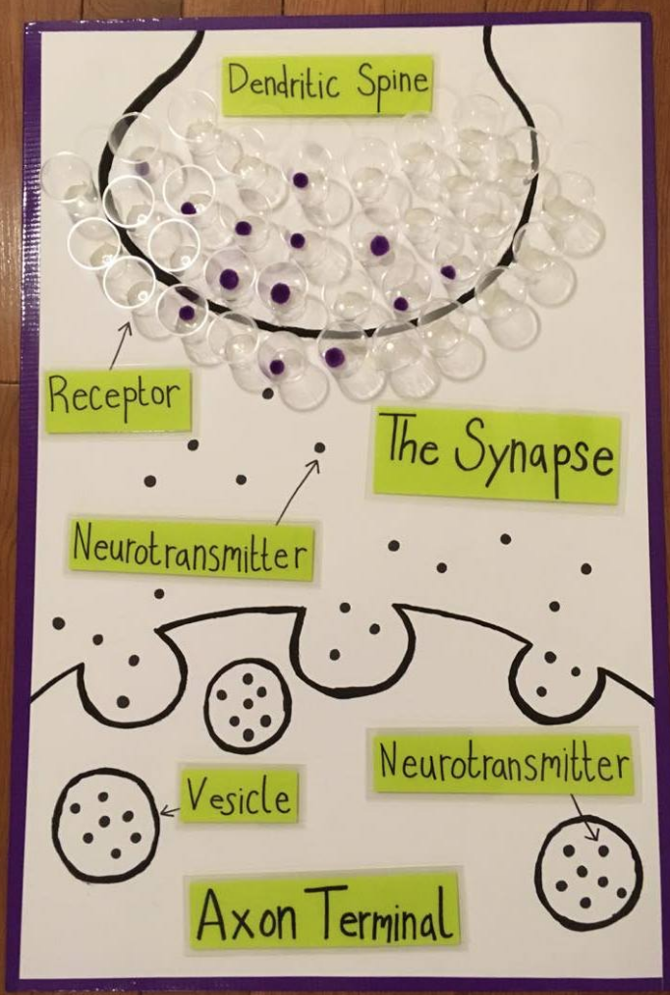 diagram of the playing table

Extra Resources:

