STROOP TEST

Topic: Attention and information processing
Developed by: CUNO graduate students
Grades: 7+ (participants must be able to read)
Vocabulary words: Attention, perception, reaction time, the “Stroop effect,” interference
Materials: Stroop test cards (4 sets: color/word match, color/word mismatch, words only, colors only) and timers

Time needed: 10-15 min

Summary: This activity illustrates the widely known phenomenon called Stroop effect, which measures how interference affects reaction time in a task. This effect was first described by J. Ridley Stroop in 1935, and is now widely used by psychologists to understand how our brain works. This task can be adapted for any ages, as long as the participants are able to read. Participants learn about this cognitive psychology phenomenon, as well as attention, interference, and reaction times. This activity should emphasize the idea that interference, or conflicting information, affects the way our brains process information.

This activity is a great way of demonstrating how our brain processes conflicting information and also of showing how psychologists and neuroscientists can measure interference in an experimental setting.

Prerequisites for Students: For any ages, as long as participants are able to read.
Learning Goals:
- Learn what the Stroop effect is
- Understand how reaction time relates to the Stroop effect
- Introduce interference as a possible explanation for the Stroop effect
- Think creatively about how variations in this task would affect reaction time

Background for instructor:
- The Stroop effect, measured by the Stroop task, is when it takes longer to name the color of a color word when the color of the ink and written word are different (incongruent information) than when they are the same (congruent information).
- By measuring the reaction time, the time the participant takes to complete a task, we can measure how difficult a task is.
- The Stroop effect can be due to interference, which happens when conflicting information is presented to us as we perform a task. When we are asked to name the color of the word instead of reading the word, our automatic impulse to read the word interferes with naming the color of the ink.

Set-up: Have your card sets organized and your timer ready to use for the activity.

Lesson Outline: Introduce yourself and start this activity by asking participants if they have every tried to pat their head with one hand and at the same time rub their belly with the other.

The goal of the Stroop test is to name the color of the word. Tell your first participant that their task is to say out loud the color of the word that is written in each flashcard, avoiding mistakes and reading out loud as quickly as possible. Give the participant the card set 1 (color/word match), and time how long it takes the participant to name the colors in this card set. You can write down how long it took them to read out loud this card set in a piece of paper to later compare the reaction times.

Next, give the volunteer card set 2 (color/word mismatch) and tell them that the instructions remain the same: they should name the color of the ink the word is written in as quickly as possible and avoiding mistakes. Time how long it takes the participant to name the colors in this set and write down the time. You will notice that the participant will take longer to name the colors in this set, since they will become distracted by the word itself as they read the color of the ink. Ask the participants if they found set 2 harder than set 1. Did they fight an urge to read the word out loud instead of naming the color of the ink? Why do they think that it takes people longer to name the colors in set 2 than in set 1?
Note: It’s more fun if the participant does not know what the punchline of the experiment is, so try not to reveal it beforehand. It’s easy to cheat at this by squinting your eyes, which will prevent you from reading the word. Make sure people are not squinting their eyes!

Ask the participants what they think would happen to the reaction times if you were testing a young child who did not know how to read or if you tested someone who could not read English. Would a young child have a hard time naming the color of the ink if they did not know how to read the words yet? Would a non-English speaker have a hard time naming the color of the ink? Perhaps interference would not occur in these scenarios because reading the words in English would not happen automatically.

To extend the discussion, you can ask participants what they think would happen if the printed words were not color words. What would happen if the printed words were words of everyday objects, such as ‘bus,’ ‘apple,’ or ‘pencil’? What would happen to reaction time if the printed words were nonsense, such as ‘asdf’?

Wrap-up, final thoughts: Our brain has to process different types of information at a time, and sometimes it takes us longer to complete a task when there is conflicting information presented to us. The Stroop test measures this interference, and scientists use it in labs to study how our brain processes information.

Bibliography:

https://www.sciencebuddies.org/science-fair-projects/project-ideas/HumBeh_p027/human-behavior/stroop-effect-brain-function#summary
http://faculty.washington.edu/chudler/words.html

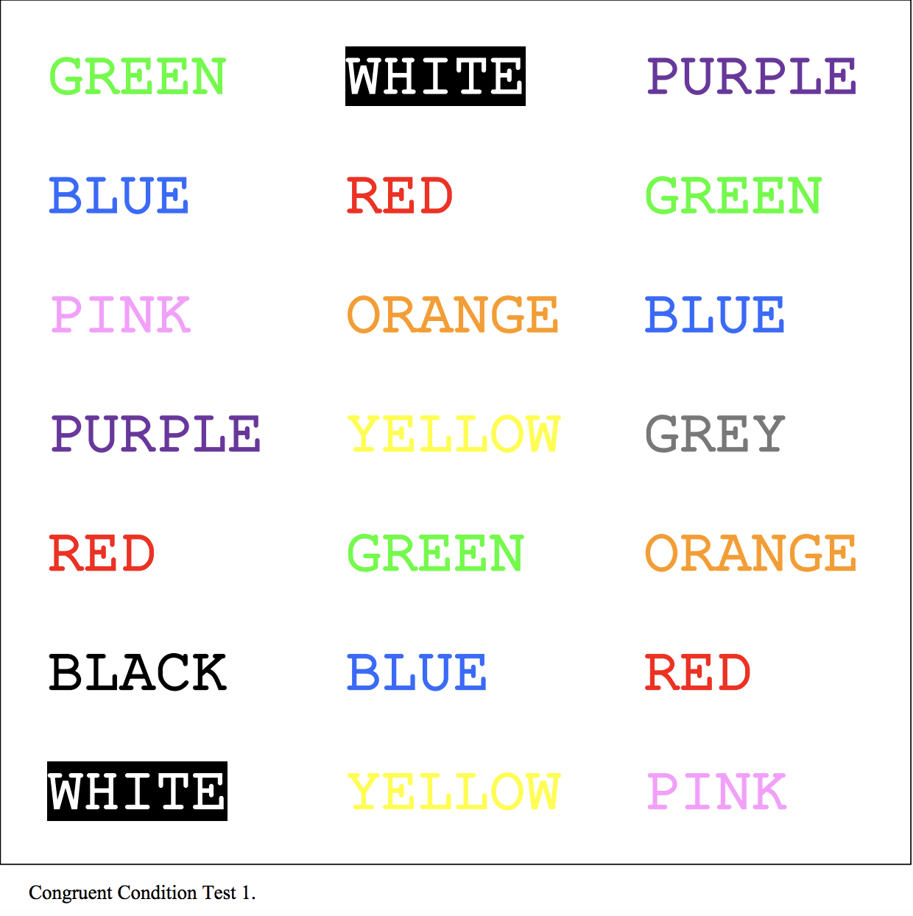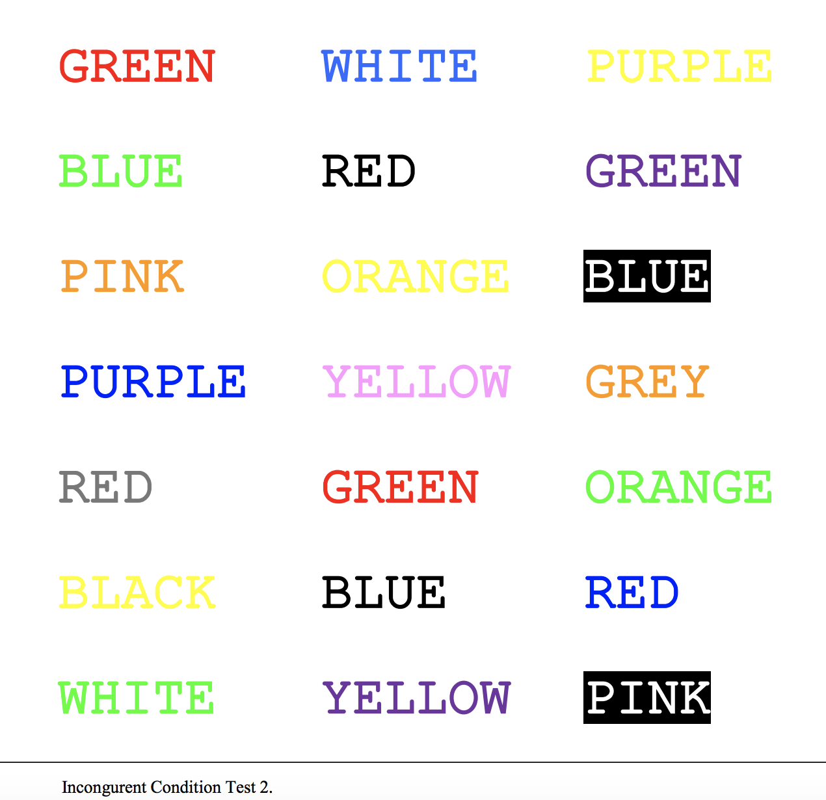

Pictures from: http://idahotc.com/Portals/0/docs/2012%20webinars/WAYPA-Session1-Stroop-Task-Handout.pdf

