Make a Neuron!

Topic: Introduction to Neurons
Developed by: CUNO graduate students, Leslie Sibener
Grades: K-5 adaptable
Vocabulary words: neuron, axon, dendrite,
Materials: pipe cleaners, diagrams of different types of neurons (motor, interneuron, sensory)

Time needed: 15-30mim (adaptable)
Introduction (2min)
Activity (5-15min): have students create their own neurons models out of pipe cleaners.
Wrap-up (5min)

Summary: This lesson is a basic introduction to the foundational unit of the brain: neurons! This can be adapted for any elementary school class. Students learn that the building blocks of brains are neurons- in all animals. The lesson should emphasize interactive discussion about the different parts of the neuron, and how all brains are made up of a network of billions of these cells.
Classes can have continuing discussion on the diversity of neuron types (motor, sensory, interneuron) if they have grasped the foundation of the different parts of the neuron (axon, dentrite, cell body/soma). This lesson is an excellent as a first lesson on neuroscience to a class, to be followed by a more specialized lesson.

Prerequisites for Students: None. Helpful if students understand the concept of cells.
Learning Goals:
- Introduce neuroscience as the study of the brain
- Learn that neurons are the building block of the brain

Background for instructor:
- Refresh basic knowledge of parts of a neuron (slides provided)
- Time spent on each section may be modified to suit each class; experience has shown that students like and tend to spend most time in the craft/building the neuron activity

Set-up: Poster board or powerpoint slide with pictures of neurons

Lesson Outline:
Ask if anyone knows what a neuroscientist is, and explain that you are in fact a neuroscientist. Discuss why the brain is interesting and important to all animals, from ants on up. Discuss parts of the brain and their functions (younger classes, less specific anatomy: the front of the brain controls decision making, the part of your brain that understands vision is actually in the back) – point to each part of your head and have them point on their own heads. Cerebellum is a good region to specifically name and discuss.
Show pictures of different animals brains if you have them, and transition into the main lesson by saying animal brains might look very different and do different things, but they are all made of the same tiny building blocks: neurons. Discuss parts of a neuron (cell body, axon, dendrites), and that neurons help all the different brain regions talk to each other like telephone poles and wires. Axons send information to other information, dendrites receive information from other neurons.
Pass out 3 different colored pipe cleaners to each student and have them build their own neurons. Leave picture of neuron on the screen, but encourage creativity. Go around to each table to help students and talk to them about their neurons. At the end of class, gather all students together to put their neurons together in one giant class “brain” - this is a good photo op for the teacher.
After students make their own neurons, have some of them explain their own models. the last optional part of this lesson is showing a picture of different types of neurons, specifically for sensory, motor, and interneurons. Sensory neurons need to receive a lot of information about the surrounding world, so they have long dendrites and shorter axons. Motor neurons need to send a lot of information across long distances (all the way to the spinal cord!), so have very long axons.

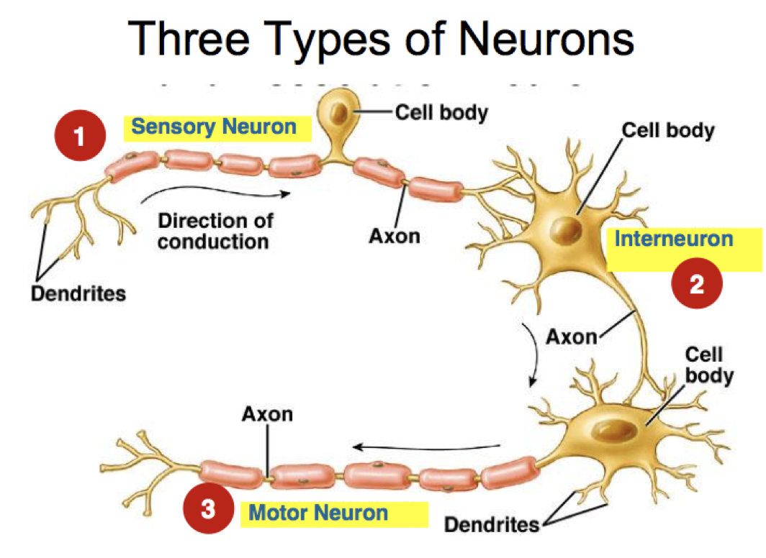

Wrap-up, final thoughts: There is a lot that is introduced here, but reinforce the idea that the brain of every animal is made of neurons that communicate with each other to control everything an animal does. Every animal is different, so every animal brain is slightly different, and as neuroscientists we can study that.

