INSTRUCTOR GUIDE

ACTIVITY TITLE: Make a Neuron!

*Theme: | Introduction to neurons
*Objective(s):  (What key learning do you want students to come away with?) | - Parts of a neuron (dendrite, axon, soma)  - Neurons communicate with one another to help us think, sense our environment, and move. This communication is in one direction (dendrite to axon).

LESSON OUTLINE:
1. Introduction:  Plan a script of what you will say to start.  - What will this be about? Why’s it interesting?  (Hook) | Qs: How does your brain help you think? What is your brain made of? (Cells)  A: Your brain is made up of ~85 billion cells! The main type of brain cells are called neurons. Today we will learn how our neurons are special, and how they work.

2. Building Background:  List questions you can use to immediately engage your audience and prepare their thinking for your activity.  -What prior knowledge might they have about/related to your topic?  -What prior knowledge (background) do they need for your activity? | In this activity we’re going to build our own neurons out of pipecleaners! We’ll explain each part of the neuron and then create our artistic interpretations.  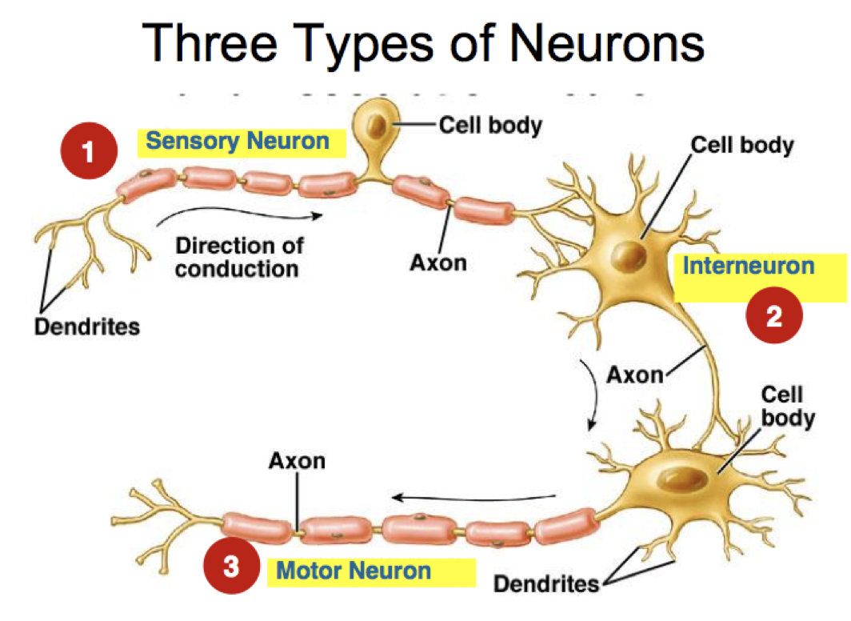

3. Lesson & Activity:  Outline the key components of your lesson.  Plan/Note:  - key ideas/ vocabulary  - scaffolds  - images/media  - extension questions  *Consider how to best deliver your content!  *Plan interactive components that encourage active thinking in your students. | - Our brain cells are called neurons- this is what they look like!  - (Show them picture of a neuron with cell body, axon, dendrite)  - Have them replicate this image out of pipe cleaners  - Have them connect neuron to other neurons in a chain- explain that neurons communicate in one direction (dendrite receives information, axon sends information).  - Axons communicate very quickly, using electricity!  - Use example to show when we use our neurons- i.e reflex- touching hot plate.  - What is another example of when you need your neurons?  - Possible extensions:  - Test their memory of the different parts  - Show them pictures of diverse types of neurons. They all have the same parts (cell body, dendrite, axons), but different shapes.  Q: Why do you think the shapes of neurons are different?  A: Neurons can have different functions- some are specialized for moving muscles, some for learning facts, some for vision.

4. Wrap Up:  - Review key ideas  - Share takeaways and final thoughts  - Discuss connections to other questions and ideas. Extensions.  - Ask: Who could you teach what you learned here today?  - Ask/Suggest: What can I do to learn more? | - There are billions of neurons in the brain, but they need to communicate with one another for you to be able to see, move, and do anything! How do they do this? (can connect to Synapse Pong Activity and teaching how neurons communicate through chemicals)

MATERIALS NEEDED: **(please list all items and quantities necessary for preparation)
Pipe cleaners for making neurons, diagrams of neurons

**attach any printouts to end of document here
Other Notes

