Action Potential Skits
Objectives:
- Introduce the basic concepts of the action potential, salutatory conduction, and neurotransmission across the synapse
- Provide an alternate teaching method in order to better engage the Sayre students and present complex topics in a more easily understood way.
Materials Needed:
- Yellow and red cards for the propagation of the action potential
- Large and small paper circles to indicate the summation of the excitatory signal at the axon hillock
- M&M’s separated by color to represent particular neurotransmitters
Preparation:
- Props for the skits will be made ahead of time
- Penn undergraduates should understand the below background information on each of the skits before teaching at Sayre. (Students with a stronger neuroscience/biology background are encouraged to take Skit 1)
A Few Words on the Lesson:
At the beginning of class, I’ll split the class roughly into halves. One half will tackle “Skit 1, The Resting and Action Potential.” This skit has multiple parts and is a bit more complicated, so two or three TAs can decide to tackle different parts with their kids. The TAs in the other half of the room can decide amongst themselves which skit they’d like to do, either Skit 2 or Skit 3.
For about 20 minutes, each group will be able to review the concept behind their skit and practice it. Afterwards, they’ll present their skit to the rest of the class, and explain the concepts behind them.
Besides getting up and being active, the students will listen to other students rather than just hearing us talk about neuroscience. Therefore, your role is to make sure that the kids understand the concepts behind their one skit, and act as a supporting role as they figure out how act out their particular project. Below, each skit is outline in as much detail as possible, but please let me know if any more clarification is needed.
Introduction (5 min):
  - introduce the concepts of the lesson, but frame the class as a performance that the students themselves will put on. We’ll also mention that they have 20 minutes to learn the material from their TAs, to understand it enough to teach it, and to act it out in a clear way so that the rest of their classmates can take notes.
Small Group Activity (15 - 20 minutes)
The small group activity for this week is really the time during which the Sayre students (with help from their undergrads) will learn the material and demonstrate their particular cellular function to the rest of the class. As a rough guide, I would spend only about 5 minutes on teaching the concept to the students. When taken as smaller components, the biology behind each individual skit isn’t too difficult – hopefully with my explanations below, demonstrations during the meeting, and your own outside research, each TA will have a firm grasp on each skit that the Sayre students are responsible for.

Biology Behind the Skits:
Skit 1, the Resting Potential and Action Potential:
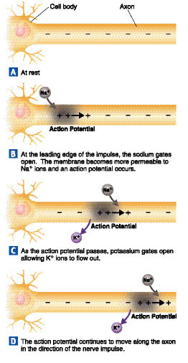

Talking Points: Sodium is on the outside of the cell and potassium is on the inside – if the two switch sides, an electric signal occurs that can be carried through the cell and down the axon.

Background Info:
A potential is simply a separation in charge, in this case separated by the phospholipid bilayer. At rest, without anything happening, there are sodium (Na⁺) ions on the outside of the cell and potassium (K⁺) ions on the inside of the cell. Due to the different concentrations of the two, the charge on the inside of the cell is negative and the charge on the outside is positive. For us, that doesn’t matter for the skit, just that sodium on the outside with potassium on the outside.
When a neurotransmitter binds to a receptor (ie on a dendrite) or there is other electrical activity moving through the cell, the action potential results. The action potential begins by sodium rushing into the cell, so the inside becomes positive. In order to counteract the new positive charge on the inside of the cell, potassium rushes out in order to get the cell to resting potential again. Most importantly, the influx of sodium and the subsequent change in charge initiates or perpetuates an electrical signal in that small portion of the membrane.
This influx of sodium into the cell triggers nearby, downstream portions of the membrane, and causes more sodium from outside of the membrane to come in. This continues all the way down to the axon terminal.
A while after the action potential fires and sends its signal down the nerve cell, a channel in the membrane called the sodium/potassium pump puts sodium and potassium back where they belong, on their respective sides of the membrane a la the resting potential.

Skit 2, Action Potential Summation:

Talking Points: Only signals that are strong enough when they summate at the axon hillock have enough energy to turn into one big signal that will travel down the axon.

Background Info:
This skit can be most easily explained by comparing the axon hillock to a dam, and signals coming from the dendrites are similar to waves hitting the dam. If the signals aren’t strong enough, it will crash against the dam without the dam breaking. However, if several big enough waves can crash against the dam at the same time, there will be enough power for the water to break through to the other side.
This analogy correlates with the axon hillock, which receives electrical signals from numerous dendrites from throughout the cell. Many of these signals won’t be strong enough (ie the small circles) in order for an action potential to be fired down the axon. However, if the signal can gather (ie five large circles at the hillock), the signal can overcome the threshold and fire one giant electrical signal in the form of an action potential.

Skit 3, Saltatory Conduction:
Talking Points: When traveling down the axon, the action potential (read: electrical signal) “jumps over” fatty Schwann cells in order to greatly increase the speed of conduction.
Background Info:

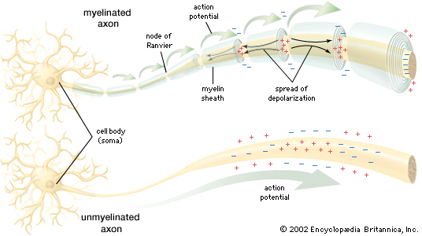
In order to better conceptualize Saltatory Conduction, imagine the axon is a series of 50 doors (with the doors being the sodium and potassium gates of depolarization/repolarization fam). If the action potential needs to actively open each one of these doors, signal conduction would take much too long. Instead, fatty Schwann cells wrap around the axon, effectively closing doors 2-49 (almost like electrical tape). In that way, only two doors need to be opened, so the signal can be transmitted more quickly. As you can see in the picture above, the only places where there is an action potential are at the Nodes of Ranvier, ie where there’s a door/channel that can be opened.
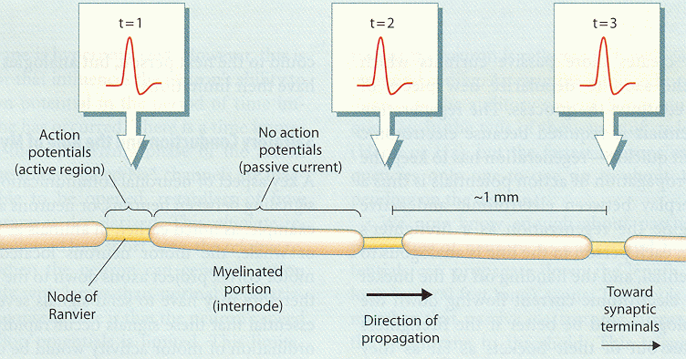
Skit 4, Neurotransmission:
(Depending on the size of the class, this skit will be added to Skit 3.)
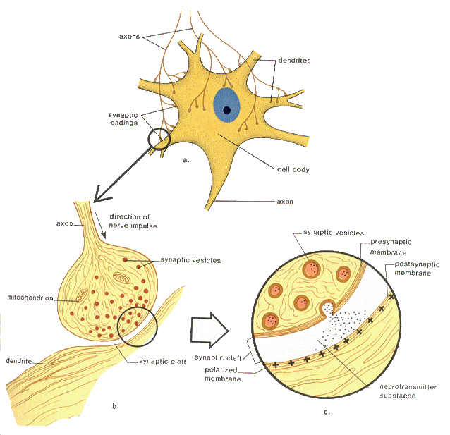

Talking Points: Certain axon terminals can release multiple neurotransmitters, but only certain neurotransmitters will bind with receptors on a neighboring dendrite.
Background Info: The heart of this exercise is that there exists a specificity between neurotransmitters released and the sort of receptors on the other side of the synapse. The best analogy I think for conceptualizing neurotransmission is the “lock and key” image. Neurotransmitters have a very specific shape, and receptors will fit perfectly to the neurotransmitter. Just like a key is made to fit into a lock, so is a neurotransmitter and its receptor.

What happens afterwards differs greatly. One possible effect is that the “lock” opens and sodium floods in, causing a depolarization (see above, Skit 1)

Large Group Activity (10 minutes):

- call all of the groups to the front of the room in numerical order to present their specific skits to the rest of the class
- With any assistance from the TAs, the students groups will present each of their skits
- As the skits proceed, the demonstration should pause and a student involved in the action should explain what exactly is happening at that moment.
- Each group should assign a narrator or a guide who can give a wrap-up at the end of the skit and explain the whole process to the class what’s going on. (The narrator can also time the action potential for Skit 3)

Skit 1, The Resting and Action Potential: The purpose of this skit is to show at the molecular level why the action potential travels down the axon. More specifically, Scott and I will specify that this skit mimics exactly what's happening at the Nodes of Ranvier on that axon and all over the dendrites/soma.
Students should be reminded that throughout the skit, they should hold their cards up so that the rest of the students can follow along with the skit.
Resting Potential:
The skit involves two rows of students facing each other, with one row all holding yellow cards (potassium ions) and another row holding red cards (sodium ions). In between them, their TA notifies the rest of the class that there exists a membrane that separates the two, with sodium/red on the outside and potassium/yellow on the inside. This is the "resting potential," which is what the neuron looks like when nothing is happening.
Action Potential, only depolarization:
Then, the TA will toss a ball to the first pair facing each other, with the ball representing a neurotransmitter. Once one pair catches the ball, the two students switch places. This is the crux of the exercise: by receiving a neurotransmitter, the two ions switch, which causes a jolt of electricity. The switching of the colors (ie the jolt of electricity) causes the neighboring pair to switch two or three seconds later. Thus, as each pair switches, the pair next to them also gets ready to switch. In this way, the signal travels down the axon. This demonstrates the "electrical signal" that travels from dendrite, through the axon, and to the terminal.
Action Potential, depolarization and repolarization:
The same group will then do the skit, but this time with repolarization. After one pair switches, they should count to 20 seconds, and switch back. This is simply to show that, while the action potential travels down the axon, there's a little bit of a delay and then the membrane returns to its resting potential eventually. Twenty seconds after the last pair switches, that pair should also switch back, and the membrane will once again resemble the resting potential.
Skit 2, Action Potential Summation: Scott and I designed this skit with an emphasis on how excitatory signals summate at the axon hillock, and only after reaching a certain strength (threshold) will the action potential travel down the axons.
One Sayre student will act as the "axon hillock," and will be receiving electrical signals from two or three different places. Attached to the axon hillock will be two or three lines of students, each resembling a long dendrite sending signals to the cell body (between 2 to 3 students per dendrite.) Either the TAs, Scott, or Iwill be passing a series of paper circles to the student at each dendrite, and this will represent the signal starting at the dendrite. At that point, the students hand off the circles down the dendrite until it stops at the student acting as the axon hillock.
However, the circles will be either small or large, and the only way for the axon hillock complete its job and start the action potential is to have five large circles. Thus, when the circles start coming down the dendrite, the axon hillock has the choice of disregarding the smaller circles (ie the weaker excitatory signals) or keeping the larger ones. The skit concludes with the axon hillock gathering five large circles and initiating the action potential.
Skit 3, Saltatory Conduction:
This skit involves a demonstration of the axon itself with Schwann cells, and eventually ending in neurotransmission. By demonstrating how quickly electricity can conduct by being able to “jump” down the axon, the students will see the inherent benefit of have myelinated axons.
One axon will act as a theoretical unmyelinated axon, and have a fair amount of kids (~6 or 7) standing in a line. Once we tell the first student to start, he/she has to high five the student next to him/her, all the way down the line until the high-fiving gets to the last person.
On another axon, there will be only 2 or 3 students, but between them, there will be a crouching student who will hold a sign that says “myelin.” We will tell them to start, and the students on either side of the Schwann cell will high five directly over the Schwann cell. We will time the two, and show how much faster the myelinated conduction occurs.
Skit 4, Neurotransmission: (This could potentially merged into skits two or three)
For this skit, Scott and I wanted to convey the sense that receptors only respond to neurotransmitters that the receptors themselves are selective for. Therefore, there will be one student who will have four or five Dixie cups with M&M’s separated by color. Separated by a space of a foot or so will be two or three other Sayre students who will be dendrites with particular receptors on them (TAs can pick which color they can receive, without telling our axon terminal). The axon terminal must then figure out which color is specific to which receptor – until the M&M’s are all eaten, of course.

